Clicking on Cart in navbar

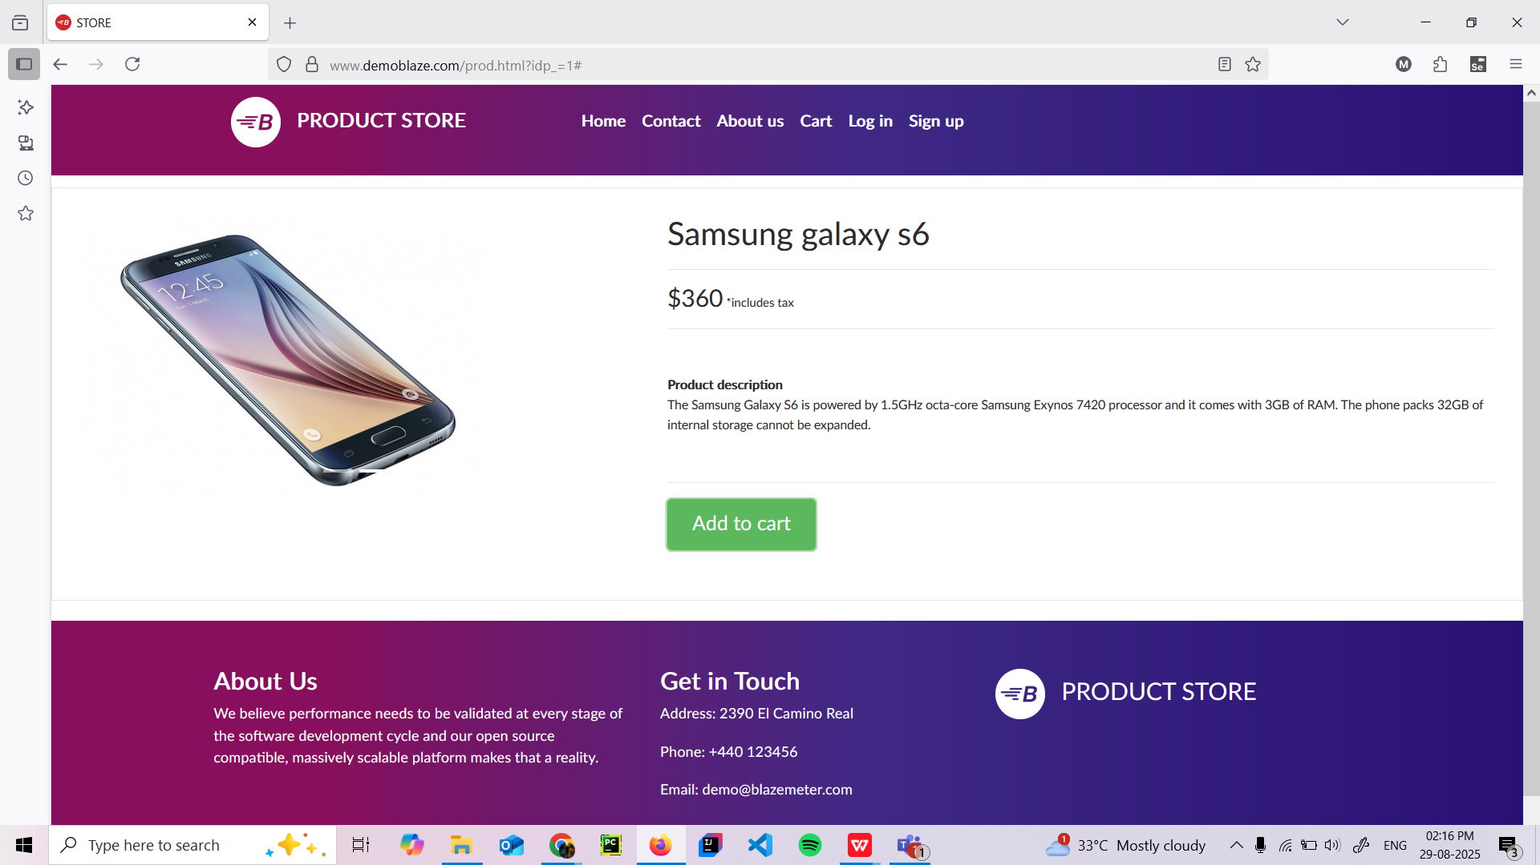

Going to cart page, multiple same products showing instead of one with number of units

